MUMScrum Application
System Requirements Document

Introduction

This Requirements Document defines the major Use Cases for the MUMScrum Application System

Table of Contents
1 Introduction 1
2 Revision History 2
3 Use Case Overview 2
4 Use Case Specification: Login to System 3
5 Use Case Specification: Product Add/edit/delete and view 4
6 Use Case Specification: User Stories add/edit/delete/veiw to product backlog 5
7 Use Case Specification: Approve or Modify Release Backlog 6
8 Use Case Specification: Create, review, update and delete sprint. 7
9 Use Case Specification: User Stories Time Estimation 8
10 Use Case Specification: Approved time estimation 9
11 Use Case Specification: Task assign 9
12 Use Case Specification: Monitor Progress 10
13 Use Case Specification: Insert Time Estimation for User Stories 11
14 Use Case Specification: Insert Job Progress update 12

Revision History
Date | Version | Description | Author
04-28-2015 | Draft | Initial Draft : | Masudur Rahman  Habib Asadur Rahman  A.K.M Sharif Uddin Ahsan  Md. Rhyhan Ahmed

Use Case Overview

Actors and their capabilities

Product owner can:
- Log in to the application system.
- Create Product Item.
- Create User Stories to product backlog.
- Approve release backlog.
- Monitor the progress.

Scrum Master can:

Login to System by username and password.
- Create, review, update and delete sprint.
- Forward user Stories Time Estimation to developer to give the timeline for every task.
- Approve time estimation with sitting with developer.
- Assign task to respective developer.
- Monitoring development Progress and check time scheduling.

Developer can:
- Log in to the application system.
- Submit time estimation for each story.
- Update remaining time for each assigned story/job.

E-Bazaar Order Entry System VisionLogin to System

Brief Description

This use case allow user to login MUMScrum with the valid userId and Password.

Actors

Product Owner, Scrum Master, Developer, Tester, HR Admin, HR Attendant, Employee

Preconditions

There should be the login credential for all user. He/She should browse the login page to login the system.

Flow of Events

Basic Flow

User Action | System Response
1. User put the valid username and password. | 1. Verify login Id and password from MUMScrum dB

Alternate Flow

User Action | System Response
1. Application provide invalid userid and password. | 1. System provide an error message and read display the login page.

Exceptional Flow
User Action | System Response
1. User already has login to the system. | 1. Display all the assigned project list.

Business Rules

Nonfunctional Requirements

E-Bazaar Order Entry System Vision Product Add/edit/delete and view

Brief Description

This use case allows the product owner to create product into mumscrum application, It also allows product owner to update product, it also allows product owner to view to the on-line mumscrum system. It also allows product owner to delete product item.

Actors

Product owner

Preconditions

Product owner should have logged in MUMScrum system and should have product owner role.

Flow of Events

Basic Flow

User Action | System Response
1. Product owner will provide product name and description and other attributes. | 1. create product page displayed
2. Product owner will provide updated product information to update | 2. Update product page displayed
3. Product owner will have to request to view specific product or product list. | 3.1 List of product page displayed.  3.2 Each product item have link to its details page.  3.3 Details link displayed product item details.

Alternate Flow

Product owner provide invalid product information such as empty product name.

User Action | System Response
1. Product owner provide invalid information’s that fails system validation tests | 1. display the invalid data and request that product owner retry valid entry

Exceptional Flow

Product owner already has a product in mumscrum system.
User Action | System Response
1. Product owner provides a product name that is already in the system DB | 1. Display a message that the product already has existence in DB. Displayed error message.

Post-Conditions
A record is added to the product DB with new product information. Product owner will see successfully done product info added into db or updated or removed into system.

Business Rules

Nonfunctional Requirements

E-Bazaar Order Entry System Vision User Stories add/edit/delete/veiw to product backlog

Brief Description

This use case allows product owner to add user stories to product backlog. It also allows this user to update the user stories from product backlog. Also have to ability to retrieve stored user stories. And also have to be able to delete user stories from product backlog.

Actors

Product owner

Preconditions

Product owner should have logged in MUM Scrum system , should have product owner role and also have to exist product item in system db.

Flow of Events

Basic Flow

User Action | System Response
1. Product owner request user stories add page. | 1. create user stories page displayed
2. Product owner will provide user stories information to add | 2. created product stories into product backlog and displayed message
2. Product owner will provide updated user stories information to update | 2. Update user stories page displayed
3. Product owner will have to request to view specific user stories or product backlog. | 3.1 List of user stories page displayed.  3.2 Each user stories item have link to its details page.  3.3 Details link displayed user stories item details.

Alternate Flow

Product owner provide invalid product information such as empty product name.

User Action | System Response
1. Product owner provide invalid information’s that fails system validation tests | 1. display the invalid data and request that product owner retry valid entry

Exceptional Flow

User Action | System Response

Post-Conditions
A record is added to the product DB with new user stories information. Product owner will see successfully done user stories info added into db or updated or removed into system.

Business Rules

Nonfunctional Requirements

E-Bazaar Order Entry System Vision Approve or Modify Release Backlog

Brief Description

This use case allows product owner to identify/select user stories from product backlog and create a new release backlog and approve it.

Actors

Product owner

Preconditions

Product owner should have logged in MUM Scrum system, should have product owner role.

Flow of Events

Basic Flow

User Action | System Response
1. Product owner will select user stories from product backlog and submit to approve release backlog | 1. Displayed message that the released backlog is successfully created.

Alternate Flow

N / A

User Action | System Response

Exceptional Flow

User Action | System Response

Post-Conditions
A record is added to the system DB with new user stories information. Product owner will see successfully done user stories info added into db or updated or removed into system.

Business Rules

Nonfunctional Requirements

E-Bazaar Order Entry System Vision Create, review, update and delete sprint.

Brief Description

This use case allows the Scrum master to create, review, update and delete the sprint.

Actors

Scrum Master

Preconditions

The Scrum master should be login to the application.

Flow of Events

Basic Flow

User Action | System Response
1. Select the specific project. | 1. Project details has been displayed to master.
2 Master can perform create, update and delete operation all the sprint. | 2. Data should be store to MUMScrum DB.
3. He can review the existing sprint. | 3. Display all the information with assign developer, timeline, status for the selected sprint.

Alternate Flow
User Action | System Response
1. Master put Invalid data for CRUD operation. | 1. System will display error message.
2 Failed to perform CRUD operation. | 2. Display the error message with detail information.

Post-Conditions
A record is added/modified to the MUMScrum DB or Deleted from the same DB.

Business Rules

master cannot modify the final sprint.

Nonfunctional Requirements

E-Bazaar Order Entry System Vision User Stories Time Estimation

Brief Description

This use case allows the Scum master to forward the sprint to developer for time estimation.

Actors

Scrum Master

Preconditions

Sprint should be available for this project in the system.

Flow of Events

Basic Flow

User Action | System Response
1. Forward sprint to developer for the time estimation. | 1. Sprint should forwarded to the developer and pop-up a successful message.
2. Review time schedule. | 2. Display the sprint with time schedule.
3. Acknowledge sprint with time schedule to product owner. | 3. Sprint should forwarded to the product owner and pop-up a successful message.

Post-Conditions
Sprint will be available to the respective developer to give the time estimation.

Business Rules

Non-functional Requirements

E-Bazaar Order Entry System Vision Approved time estimation

Brief Description

This use case allows the Scum master to approve estimation time given by developer.

Actors

Scrum Master

Preconditions

Sprint should be available with the given timeline for this project in the system.

Flow of Events

Basic Flow

User Action | System Response
1. View the sprint with estimated time. | 1. Display the sprint with detail time schedule.
2. Review and approved time schedule. | 2. Display the sprint with time schedule and show the pop-up message after approval.
3. Acknowledge sprint with time schedule to product owner. | 3. Sprint should forwarded to the product owner and pop-up a successful message.

Post-Conditions
Estimated time has been approved for the respective sprint with mutual understanding of master and developer.

Business Rules

Non-functional Requirements

E-Bazaar Order Entry System VisionTask assign

Brief Description

This use case allows the master to assign task to developer.

Actors

Scrum master

Preconditions

Sprint must be approved by the product owner with timeline.

Flow of Events

Basic Flow

User Action | System Response
1. View the final sprint. | 1. Display the final sprint.
2. Assign task to the developer. | 2. Task has been assign to developer and display successful message.

Post-Conditions
Task has been assign to the developer and store all the data to the DB.

Business Rules

Non-functional Requirements

E-Bazaar Order Entry System VisionMonitor Progress

Brief Description

This use case allows master view the progress of the ongoing project/task.

Actors

Scrum master

Preconditions

Ongoing project should be assigned to the master.

Flow of Events

Basic Flow

User Action | System Response
1. Monitoring the progress report. | 1. Display progress report with completed task, ongoing task and pending task.

Post-Conditions

Business Rules

Non-functional Requirements

E-Bazaar Order Entry System VisionInsert Time Estimation for User Stories

Brief Description

This use case allows the developer to submit estimation time for each user stories.

Actors

Developer

Preconditions

Developer must be a valid employee in HR sub system should have a developer role. User should login to the MUMScrum to perform this task.

Flow of Events

Basic Flow

User Action | System Response
1. Developer selects single user story | 1.Display estimation time input box along with hours and day check box.
2. Developer fills in estimation text box and submit it. | 2. Notify the scrum master that developer submit their estimation.

Exceptional Flow

Developer not eligible to submit estimation.
User Action | System Response
1. Developer attempts to log into MUMScrum system | 1. Display a message that the developer is not eligible to login to the system.

Post-Conditions
A record is added to the system recording that the developer has submitted anestimation report.

Business Rules

Nonfunctional Requirements

E-Bazaar Order Entry System VisionInsert Job Progress update

Brief Description

This use case allows the developer to update remaining time for each job/story he is performing.

Actors

Developer

Preconditions

Developer must be a valid employee in HR sub system. User should login to the MUMScrum to perform this task.

Flow of Events

Basic Flow

User Action | System Response
1. Developer selects single user story | 1. Display remaining time input box along with his/her estimation time from assigned story list.
2. Developer fills in estimation text box and submit it. | 2. Notify the scrum master that developer update estimation.

Exceptional Flow

Developer not eligible to update estimation.
User Action | System Response
1. Developer attempts to log into MUMScrum system | 1. Display a message that the developer is not eligible to login to the system.

Post-Conditions
A record is added to the system recording that the developer has updated anestimation report.

Business Rules

Nonfunctional Requirements

Keywords | Description
Product Owner | Person responsible for managing product backlog, release backlog, approve sprint
Scrum Master | Person responsible for assigning jobs to developers, create and modify sprint and monitoring the progress.
Developer | Person responsible for estimating required time for each user story and update remaining time for each assigned job/task.
Tester | Person responsible for testing each user stories assigned by Scrum Master
HR Admin | Person responsible for managing whole HR subsystem.
Employee | Person who serve the company and play certain role.
HR Attendant | Person responsible for preparing graphical calendar system.

Use Case Module Assignments

1 | Login System | Masud
2 | Product Add/edit/delete and view – Product Owner | Habib
3 | User Stories add/edit/delete/view to product backlog – Product Owner | Masud
4 | Approve or Modify Release Backlog - Product Owner | Habib
5 | Create, review, update and delete sprint – Scrum Master | Sharif
6 | User Stories Time Estimation – Scrum Master | Sharif
7 | Approved time estimation – Scrum Master | Rhyhan
8 | Task assign – Scrum Master | Rhyhan
9 | Insert Time Estimation for User Stories – Developer | Masud/Rhyhan
10 | Insert Job Progress update – Developer | Habib/Sharif

Use Case Diagram for MUMScrum:

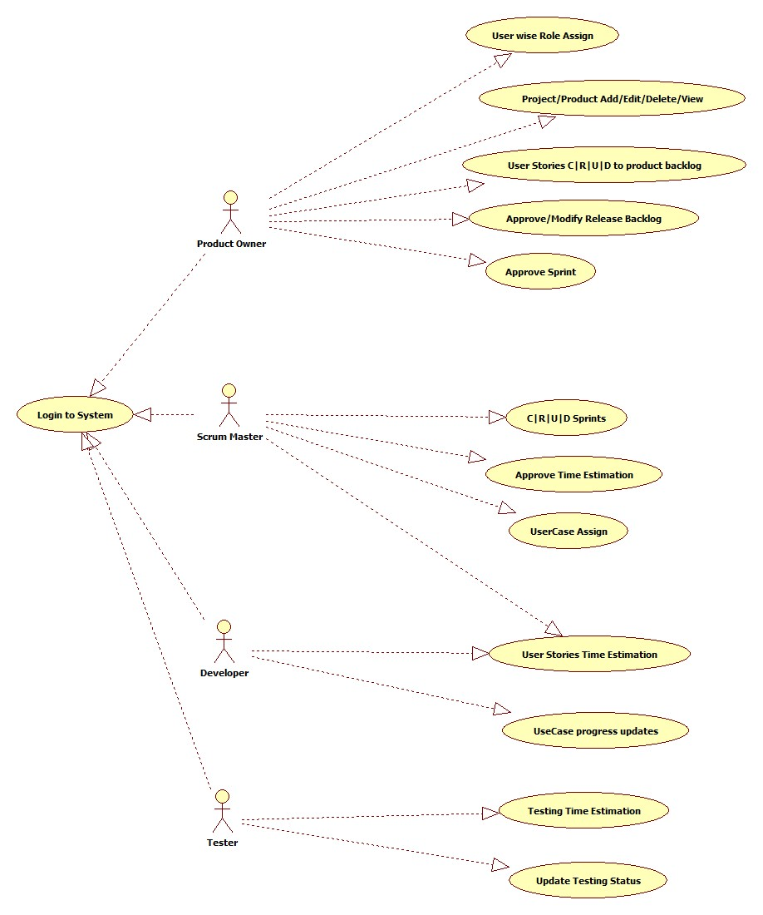

Use Case Diagram for HR Subsystem:

